Assignment 1: Breadth First Search (BFS)

Assume you have to travel from ***Arad*** city to ***Bucharest*** city. You desire to travel this route by covering shortest distance. Following is a road-map. You can consider the cost of moving from one city to another is same. There remains multiple shortest paths to reach ***Bucharest*** city.

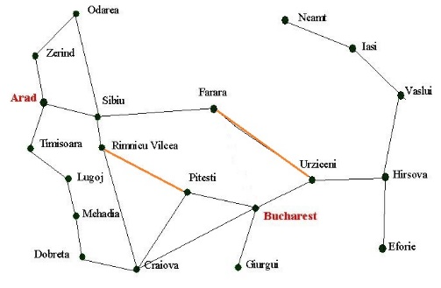

You have to be careful while traveling as some intermediate paths are broken (orange colored roads). You should avoid those routes.

**Input:**

You’ll be given the information of the map, blocked roads, the locations of your starting and the destination city. We’re providing you a sample input (the information needed for the above map) to help you understand the input format.

20 24 (MxN -> Maze dimension: row x column)

***Arad*** (Starting Location)

***Bucharest*** (Destination Location)

2 (#broken roads)

Farara,Urziccini

Riminecu, Pitesi

[information of 24 roads]

Odarea,Sibiu

……,……

……………………

..

.

**Output:**

Explore the map to provide a safe route for you using the BFS search algorithm. Consider the route safe only when it does not contain any broken road and covers the shortest distance. If there exists no safe route you will print the shortest route(s) containing the broken roads.